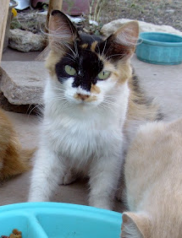
Missing Cat
Clementine

Missing from ~2100 Gatlin Creek Road area
(Dripping Springs)
Adult Calico Cat:
Medium size
Left Ear is “tipped”
She is spayed and current on rabies shot.
She is shy to strangers but friendly when knows you and loves to be brushed and climb on your lap.
REWARD. Call Chris anytime @ 830-225-0319

